Software Requirement Engineering (SWE-302)- Semester Project
Project Title: Pharmacy Management System
(A Digital Solution for Efficient Pharmacy Operations)
Task: Software Requirement Specification (SRS-Document)

Prepared By:
Munesh Kumar
CMS ID: 053-24-0037

Instructor:
Dr. Qamar Uddin Khand



Department: Computer Science
Program: Software Engineering
Semester-IV-Section-A
(Spring-2026)
Sukkur Institute of Business Administration
Table of Contents
1. Introduction 5
1.1 Overview of Pharmacy Management System 5
1.2 Why Local Pharmacies Need Digital Systems 5
2. Purpose of the System 6
2.1 Stock Management 6
2.2 Billing and Invoice Generation 6
2.3 Reports 6
2.4 Supplier Records 6
2.5 Reducing Manual Work 6
3. Scope of the System 7
3.1 Local Medical Stores 7
3.2 Pharmacies in Hospitals and Clinics 7
3.3 Standalone Medicine Shops 7
4. Objectives 8
5. Context Analysis 9
5.1 Current Manual Pharmacy System 9
5.2 Common Problems in Manual Systems 9
5.2.1 Paper Records 9
5.2.2 Slow Billing 9
5.2.3 Stock Issues 9
5.2.4 Expiry Medicine Issues 9
5.2.5 No Reporting 9
5.3 Opportunity for Digital System 10
5.4 Need for New System 10
6. Feasibility Study 11
6.1 Technical Feasibility 11
6.2 Economic Feasibility 11
6.3 Operational Feasibility 11
6.4 Schedule Feasibility 12
7. Stakeholder Analysis 13
7.1 Primary Stakeholders 13
7.1.1 Pharmacy Owner 13
7.1.2 Pharmacy Staff 13
7.1.3 Cashier 13
7.2 Secondary Stakeholders 13
7.2.1 Customers 13
7.2.2 Suppliers 14
7.2.3 Developer / IT Support 14
8. Requirement Elicitation 15
8.1 Interview 15
8.2 Observation 15
8.3 Questionnaire 16
8.4 Discussion and Brainstorming 16
9. Functional Requirements 18
10. Non-Functional Requirements 20
11. Use Cases 22
UC-01: User Login 22
UC-02: Add Medicine 22
UC-03: Search Medicine 22
UC-04: Generate Bill 23
UC-05: View Reports 23
UC-06: Update Stock 23
12. System Diagrams 25
12.1 Use Case Diagram 25
12.2 Context Diagram 26
12.3 Sequence Diagram 27
12.3 User Interface Mockups 28
13. Proposed Solution 30
14. Conclusion 31
15. References 32
16. Appendices 33
16.1 Tool Used: 33
16.2 Plagiarism Report: 33
16.3 AI Report: 34

1. Introduction

1.1 Overview of Pharmacy Management System
A Pharmacy Management System is a computer application that makes things easier for pharmacies and drug stores. The Pharmacy Management System helps with things like managing medicine inventory, billing making a list of vendors making a list of patients and making reports. Using the Pharmacy Management System is better than using a system because it helps employees do their jobs better and faster.
The Pharmacy Management System keeps track of all the drugs in the store. Every time the inventory changes the system updates its records. This way the pharmacy always knows how many drugs are in stock.
A good Pharmacy Management System should also be able to warn when drugsre about to expire. This helps prevent selling expired drugs to customers. The Pharmacy Management System should also be able to make reports on sales and inventory.

1.2 Why Local Pharmacies Need Digital Systems
Most local pharmacies in Pakistan still use processes like paper registration, handwritten bills and manual inventory management. These processes take a lot of time. Can have mistaken.
Digital processes are better because they are faster and more accurate. With processes pharmacies can quickly find medicines automatically make bills and keep inventory information up to date.
Digital processes also help with keeping records for audits. So using systems is very important for pharmacies to grow and develop their businesses. The Pharmacy Management System is a part of this digital process, for pharmacies.

2. Purpose of the System
The main goal of creating the Pharmacy Management System is to make a system that is easy to use and reliable. This system will help get rid of the ways that local pharmacies use. The Pharmacy Management System will do things, which are listed below.

2.1 Stock Management
One of the important jobs for the pharmacy is to keep track of the medicines they have in stock. The Pharmacy Management System lets the pharmacist create, change, delete and check the medicines stock records. The stock will be updated by itself after each sale so the pharmacist will know how many medicines are left in stock.

2.2 Billing and Invoice Generation
The Pharmacy Management System makes the billing process automatic. When a customer buys medicine the staff member picks the items and the system calculates the bill, including any discounts. The system then makes an invoice and gives it to the customer. This helps prevent mistakes and saves time at the counter.

2.3 Reports
The Pharmacy Management System also gives the pharmacy owner reports to help them see how their business is doing. These reports include sales reports, monthly financial reports, stock reports, expiration date reports and reports on payments to suppliers.

2.4 Supplier Records
Each pharmacy works with medicine suppliers. The Pharmacy Management System keeps track of all the supplier’s information, such as their contact details the types of medicines they supply and the history of payments. This makes it easy to get in touch with a supplier.

2.5 Reducing Manual Work
To sum it up the Pharmacy Management System is designed to make things easier, for people. Tasks that used to take a time can now be done quickly. This means the staff does not have to work hard which helps prevent mistakes that people can make. The Pharmacy Management System is meant to make the pharmacy run smoothly and efficiently.

3. Scope of the System
The Pharmacy Management System is made for different kinds of medical retail businesses. This system can be used by the following types of places:

3.1 Local Medical Stores
medium sized medical stores in cities and towns can use the Pharmacy Management System to manage what they do every day. These stores sell a lot of medicines and deal with many people each day. The Pharmacy Management System helps them stay organized and work well without needing a lot of staff.

3.2 Pharmacies in Hospitals and Clinics
Pharmacies in hospitals and clinics have to deal with a lot of prescriptions and medicines. The Pharmacy Management System is good for these places because it makes billing makes it easy to find medicines and keeps track of stock accurately which is very important in hospitals and clinics where speed and accuracy can affect people’s health.

3.3 Standalone Medicine Shops
Small medicine shops in neighborhoods or markets can also use the Pharmacy Management System. It makes billing and managing stock easier so the owner can focus more on the people who come to the shop.
The Pharmacy Management System works on a desktop computer. Stores its information on that computer. It does not need the internet to work so it can be used in places where the internets not always available. The first version of the Pharmacy Management System is, for one store only. It will be able to support many stores in the future.

4. Objectives
The main goals of this project are:
- To build a Pharmacy Management System for pharmacy tasks.
- To switch from records and billing to a digital system.
- To ensure authorized users can log in securely.
- To handle medicines by adding, editing, deleting and searching for records easily.
- To keep track of stock levels automatically.
- To create bills and receipts for customers.
- To send reminders for medicines that're about to expire.
- To keep supplier records organized.
- To generate reports on sales and stock.
- To design a system that's easy to use for pharmacy staff.
- To make the Pharmacy Management System dependable, safe and fast.
- To improve pharmacy operations, with the Pharmacy Management System.

5. Context Analysis

5.1 Current Manual Pharmacy System
In the existing manual system used by most local pharmacies, all records are maintained through paper-based methods. The pharmacist or staff writes down medicine names, quantities, and prices in physical registers. Bills are calculated manually using a calculator or even mental arithmetic, and invoices are written by hand on paper slips. Customer records, if maintained at all, are stored in physical files that are difficult to search or organize.

5.2 Common Problems in Manual Systems
The manual approach comes with several serious problems that affect both efficiency and accuracy:

5.2.1 Paper Records
Paper registers are prone to damage, loss, and illegibility. Over time, handwriting becomes hard to read, pages tear, and records get misplaced. Searching through hundreds of pages to find a specific medicine or transaction is time-consuming and unreliable.

5.2.2 Slow Billing
Manual billing is a slow process. The cashier must look up prices, calculate totals, write the invoice, and collect payment, all while the customer waits. During busy hours, this creates long queues and customer dissatisfaction.

5.2.3 Stock Issues
Without a digital system, it is nearly impossible to track stock accurately. Medicines run out without warning, leading to situations where customers are told an item is unavailable when it may actually still be in storage. Alternatively, over-ordering leads to unnecessary expense.

5.2.4 Expiry Medicine Issues
Managing medicine expiry dates manually is extremely challenging. With hundreds or thousands of different medicines in stock, keeping track of expiry dates using a register is impractical. Expired medicines often remain on the shelf and may be accidentally sold to customers, which is both dangerous and illegal.

5.2.5 No Reporting
Manual systems provide no easy way to generate sales reports, profit analyses, or inventory summaries. The pharmacy owner has no quick way to know how much revenue was generated in a given period or which medicines are selling most. This lack of data makes business planning very difficult.

5.3 Opportunity for Digital System
A Pharmacy Management System is really good for the pharmacy business. It helps in ways.
- The billing system is fast and accurate.
- Customers do not have to wait for a time.
- When a medicine is sold or bought the stock is updated automatically by the Pharmacy Management System.
- You can easily check which medicines are available in the pharmacy.
- If you need to find a medicine you can search for it by name quickly with the Pharmacy Management System.
- The Pharmacy Management System sends alerts when medicines are, near expiry.
- The Pharmacy Management System keeps records securely.
- It is easy to manage records of suppliers with the Pharmacy Management System.
- The Pharmacy Management System can generate sales and stock reports easily.
- The Pharmacy Management System reduces mistakes that people make.
- The pharmacy business can give service to customers with the Pharmacy Management System.
- The Pharmacy Management System helps the owner make business decisions with its reports.
- The staff and owner save time with the Pharmacy Management System.
- The Pharmacy Management System supports the growth and modernization of the pharmacy business.

5.4 Need for New System
We need a digital system to make things work better at the pharmacy. This digital system will help the pharmacy reduce mistakes and save time. The pharmacy will be able to provide customer service with this new digital system.
The new digital system will help the pharmacy grow. It will help the pharmacy manage operations in a professional way. The pharmacy will be more efficient, with the digital system.

6. Feasibility Study
We need to see if a project is possible before we start working on it. This is done by doing a study to find out if the project is something we can really do if we can afford it and if we can get it done with the resources we have. We are going to look at the Pharmacy Management System in a few ways to see if it is a good idea.

6.1 Technical Feasibility
The Pharmacy Management System is something we can definitely make. We need to see if we have the technology and tools to build it. We can make the Pharmacy Management System using things, like Python or Java a MySQL database and a simple graphical user interface that people can use.
The equipment we need is not special. We can use a desktop computer or laptop to run the Pharmacy Management System. We can also use a printer to print invoices and the internet to make updates to the Pharmacy Management System on.
So, the Pharmacy Management System project is something we can do because we have all the tools, software and skills we need to make the Pharmacy Management System.

6.2 Economic Feasibility
The Pharmacy Management System is something we need to make sure we can afford. We can use tools and software to build the Pharmacy Management System, which means we do not have to spend a lot of money to develop it.
The Pharmacy Management System will help us save money on things like paper and bills. It will also save us time because we will not have to do everything by hand. The Pharmacy Management System will help us keep track of our stock and make sure our bills are correct so we will not lose money because of mistakes or old medicines.
So, the Pharmacy Management System project is an idea because the good things it will do for us in the long run are more important, than the money it will cost us to build the Pharmacy Management System.

6.3 Operational Feasibility
The Pharmacy Management System is something that can be used every day in a pharmacy. This system is made to be simple and easy to use so people who work at the pharmacy can use it without any problems.
The staff will only need to learn a thing to use the system. The Pharmacy Management System will have buttons and simple forms that make sense so it will be easy for people to figure out.
The Pharmacy Management System is an idea because it works well with how pharmacies normally operate and the Pharmacy Management System is not hard to use.

6.4 Schedule Feasibility
Schedule feasibility checks if the system can be finished on time.
The Pharmacy Management System can be completed in a timeline based on the project scope.
We check if there is time to complete the Pharmacy Management System.
This is based on the project scope.
The timeline, for the Pharmacy Management System is realistic.
It is based on a check of the available time and the project scope of the Pharmacy Management System, following table shows how project will build in each phase:
Phase | Activity | Duration
1 | Requirements Gathering and Analysis | 1 Week
2 | System Design | 1 Week
3 | Database Setup | 3 Days
4 | Core Module Development | 2 Weeks
5 | Testing and Bug Fixing | 1 Week
6 | Deployment and Training | 2 Days

Note: I think we can finish the project in about five to six weeks. That sounds like a timeline, to me. So, the project seems doable in terms of scheduling.

7. Stakeholder Analysis
The people who have a say, in the system are called stakeholders. These stakeholders are people who will use the system or the system will affect their work. We need to know what the stakeholders do so the system can meet the needs of all the stakeholders. This is important because the stakeholders are the people who will be using the system and the system needs to work for all the stakeholders.

7.1 Primary Stakeholders
Primary stakeholders are the people who use the system every day.

7.1.1 Pharmacy Owner
The pharmacy owner is the person in charge and the one who benefits the most from the system. The owner will use the system to look at business reports check stock levels track payments to suppliers and keep an eye on how the pharmacy's doing. The system lets the owner see what is happening in the business without having to check the registers by hand.

7.1.2 Pharmacy Staff
The staff are in charge of managing the medicines updating the stock and helping the customers. They will use the system to add medicines update the records search for medicines and check if the stock is available. The system makes their daily work easier. Saves them time on paperwork.

7.1.3 Cashier
The cashier is the person who handles the sales and the billing. The cashier will use the billing part of the system to select the medicines the customers bought make invoices and take payments. The system makes this process faster and more accurate than doing it by hand.

7.2 Secondary Stakeholders
Secondary stakeholders do not use the system directly. They are affected by how it works.

7.2.1 Customers
The customers benefit from the system even though they do not use it. They get to wait for time at the counter because the billing is faster. The system also helps make sure the medicines they need are available because the stock records are accurate. The system checks the expiry dates of the medicines so the customers only get valid medicines.

7.2.2 Suppliers
The suppliers are affected by the system because it keeps track of all the orders and payments. This helps the pharmacy and the suppliers communicate better. The suppliers can expect to get paid on time and, in an organized way when the pharmacy uses the system.

7.2.3 Developer / IT Support
The developer is the person who designs builds and takes care of the system. The developer talks to all the stakeholders to understand what they need how the business works and to make sure the system meets everyone’s needs. After the system is up and running the developer may also provide help and updates when needed.

8. Requirement Elicitation
The Pharmacy Management System requires a lot of information from stakeholders to understand what the system must do. To collect requirements for the Pharmacy Management System several methods were used.
The Pharmacy Management System needs to be understood by the stakeholders so the Pharmacy Management System team gathered information from them.

8.1 Interview
The Pharmacy Management System team conducted interviews with the pharmacy owner, the cashier and the staff members to understand their challenges and expectations from the new Pharmacy Management System.
The Pharmacy Management System team asked ended questions to gather detailed information about the Pharmacy Management System.
Key findings from the interviews about the Pharmacy Management System include the need for billing, medicine search functionality and automated stock updates for the Pharmacy Management System.
Sample Interview Questions about the Pharmacy Management System:
- What are the biggest problems you face with the manual system for the Pharmacy Management System?
- How do you currently track medicine stock for the Pharmacy Management System and what difficulties do you face?
- How long does it take to generate a bill for a customer in the Pharmacy Management System?
- How do you manage medicines in the Pharmacy Management System and how often do issues occur?
- What kind of reports do you need to manage the business for the Pharmacy Management System?

8.2 Observation
The Pharmacy Management System development team visited a local pharmacy to observe how daily operations are carried out for the Pharmacy Management System.
The observation about the Pharmacy Management System helped identify inefficiencies that staff may not have mentioned during interviews, such as the time spent searching for medicine prices in a register and the confusion caused by handwriting for the Pharmacy Management System.
The observations about the Pharmacy Management System confirmed the need for a search feature and a clear billing interface for the Pharmacy Management System.

8.3 Questionnaire
A structured questionnaire was distributed to pharmacy staff to gather data about their preferences and system requirements for the Pharmacy Management System.
Questions were designed to identify the critical features and any concerns about switching to a digital Pharmacy Management System.
Sample Questionnaire Items about the Pharmacy Management System:
- On a scale of 1 to 5 how difficult is it to find medicine records in the system for the Pharmacy Management System?
- Do you think a digital billing system would improve your work speed for the Pharmacy Management System? (Yes / No)
- Which feature do you consider important for the Pharmacy Management System: stock alerts, fast billing or supplier tracking?
- How comfortable are you using computer-based software on a basis for the Pharmacy Management System?

8.4 Discussion and Brainstorming
A group discussion was held with all stakeholders, including the owner, staff and the Pharmacy Management System development team.
This session about the Pharmacy Management System helped prioritize requirements and resolve any expectations about the Pharmacy Management System.
The discussion about the Pharmacy Management System confirmed that the system should be simple enough for users with computer skills to operate without difficulty.
Key Findings from Elicitation Activities about the Pharmacy Management System:
- The urgent need for the Pharmacy Management System is fast and accurate billing to reduce customer waiting time.
- Medicine search by name is a high-priority feature for all staff members for the Pharmacy Management System.
- Expiry date alerts are considered essential for safety and legal compliance for the Pharmacy Management System.
- Reporting features are important for the owner. Not required to be complex for the Pharmacy Management System.
- Users prefer an interface with large buttons and clear labels, for the Pharmacy Management System.

9. Functional Requirements
Following are the requirements:
FR01 – User Login
The system will let users who are allowed to log in using their username and password.
User: All Users
FR02 – Add Medicine
Staff can add medicines. They will enter details like name, category, price, quantity and expiry date.
User: Staff / Owner
FR03 – Edit Medicine
We can update medicine records. Staff or the owner can change the price, quantity or other details.
User: Staff / Owner
FR04 – Delete Medicine
If a medicine is no longer used, authorized users can remove it from the system.
User: Staff / Owner
FR05 – Search Medicine
Users can search for a medicine by its name or category. The search will work fast.
User: All Users
FR06 – Billing
The cashier can choose medicines. Create a bill. The total amount will be calculated automatically.
User: Cashier
FR07 – Print Invoice
The system will create an invoice for each customer transaction and print it.
User: Cashier
FR08 – Update Stock
The stock levels will update automatically after each sale or when a new purchase is entered.
User: Staff / Owner
FR09 – Supplier Management
The system will keep records of suppliers. This will include their name, contact details and the medicines they supply.
User: Owner
FR10 – Sales Reports
The system will generate reports on sales. These reports will be for each day, week and month.
User: Owner
FR11 – Expiry Alerts
The system will show alerts for medicines that're, about to expire.
User: Staff / Owner
FR12 – Logout
All users can log out of the system securely. This will protect their session.
User: All Users

10. Non-Functional Requirements
NFR01 – Security
The system needs a username and password to log in. People who are not allowed to use the system should not be able to get in. All important information will be kept safe in the database. The system will make sure that authorized people can see sensitive data. Security is very important for the system. The system will keep all data secure.
NFR02 – Performance
When you use the system it will respond quickly. It will answer your questions. Find what you need in two seconds or less. If you need to make a bill the system will do it in three seconds or less. The system will always try to be fast. The system will respond to user inputs and search queries quickly.
NFR03 – Reliability
The system will not stop working when you are using it. If you put information into the system, it will not get lost. The system will have a plan. The system will keep your information safe. The system will be stable. It will not crash.
NFR04 – Usability
The system will be easy to use. People who work in pharmacies will be able to learn how to use it. The system will have menus and buttons that are easy to understand. The system will be intuitive.
NFR05 – Backup
The system will make copies of all the information. If something goes wrong with the hardware, we can still get the information back. The system will support data backup. The system will keep your information safe.
NFR06 – Scalability
The system will be able to grow and change. We can add features to the system later. The system will be designed to be scalable. The system will be able to support features like multi-branch support or mobile access.
NFR07 – Availability
The system will be available when the pharmacy is open. We will do maintenance when the pharmacy is closed. The system will be available for use during all pharmacy operating hours. The system will be available for 10 to 14 hours, per day.
NFR08 – Accuracy
The system will make sure that all the numbers are correct. It will not make mistakes when it is doing math. The system will be accurate. All billing calculations and stock updates will be 100% mathematically accurate.

11. Use Cases
A use case describes a specific interaction between a user (actor) and the system to achieve a particular goal. The following use cases have been identified for the Pharmacy Management System.

UC-01: User Login
Use Case ID | UC-01
Use Case Name | User Login
Actor | Admin, Staff, Cashier
Description | This use case allows an authorized user to access the system by entering valid login credentials.
Precondition | The system is running and the login page is displayed.
Main Flow | 1. User enters username and password. 2. System validates the credentials. 3. If valid, user is granted access to the dashboard. 4. If invalid, an error message is displayed.
Postcondition | The user is successfully logged in and can access system features.
Alternate Flow | If the user enters incorrect credentials three times, the account is temporarily locked.

UC-02: Add Medicine
Use Case ID | UC-02
Use Case Name | Add Medicine
Actor | Staff, Owner
Description | This use case allows authorized staff to add a new medicine record to the system.
Precondition | The user is logged in and has access to the medicine’s module.
Main Flow | 1. User opens the Add Medicine form. 2. User enters medicine name, category, quantity, price, and expiry date. 3. User clicks the Save button. 4. System validates the data and saves the record. 5. Confirmation message is displayed.
Postcondition | The new medicine is added to the inventory and is visible in the medicine list.
Alternate Flow | If required fields are empty, the system displays a validation error and does not save.

UC-03: Search Medicine
Use Case ID | UC-03
Use Case Name | Search Medicine
Actor | All Users
Description | This use case allows users to search for a specific medicine by name or category.
Precondition | The user is logged in and the medicine database contains records.
Main Flow | 1. User types the medicine name or category in the search box. 2. System searches the database. 3. Matching results are displayed in a list. 4. User selects the desired medicine for more details.
Postcondition | The user can view complete details of the searched medicine.
Alternate Flow | If no matching medicine is found, the system displays a 'No results found' message.

UC-04: Generate Bill
Use Case ID | UC-04
Use Case Name | Generate Bill
Actor | Cashier
Description | This use case allows the cashier to create a bill for a customer purchase and print an invoice.
Precondition | The cashier is logged in and medicines are available in the system.
Main Flow | 1. Cashier selects the billing option. 2. Cashier searches and adds medicines to the bill. 3. System automatically calculates the total. 4. Cashier confirms the bill. 5. System generates an invoice and prompts for printing.
Postcondition | The bill is saved in the system, stock is updated, and the invoice is printed for the customer.
Alternate Flow | If a selected medicine is out of stock, the system warns the cashier before adding it to the bill.

UC-05: View Reports
Use Case ID | UC-05
Use Case Name | View Reports
Actor | Owner
Description | This use case allows the pharmacy owner to view and download business reports.
Precondition | The owner is logged in and transaction data exists in the system.
Main Flow | 1. Owner selects the Reports section. 2. Owner chooses report type (sales, stock, expiry, supplier). 3. Owner selects the date range. 4. System generates and displays the report. 5. Owner can print or export the report.
Postcondition | The owner receives an accurate report for the selected time period and category.
Alternate Flow | If no data exists for the selected period, the system notifies the user that no records are available.

UC-06: Update Stock
Use Case ID | UC-06
Use Case Name | Update Stock
Actor | Staff, Owner
Description | This use case allows staff to manually update medicine stock quantities when new supplies arrive.
Precondition | The user is logged in and the medicine record exists in the system.
Main Flow | 1. User navigates to the stock management section. 2. User selects the medicine to update. 3. User enters the new quantity received. 4. System updates the stock level. 5. A confirmation message is displayed.
Postcondition | The medicine stock is updated and the new quantity is reflected across all modules.
Alternate Flow | If the user enters a negative quantity, the system shows an error and does not update.

12. System Diagrams

12.1 Use Case Diagram
The use case diagram below Figure-01 illustrates the interactions between different actors (users) and the system's core functionalities.
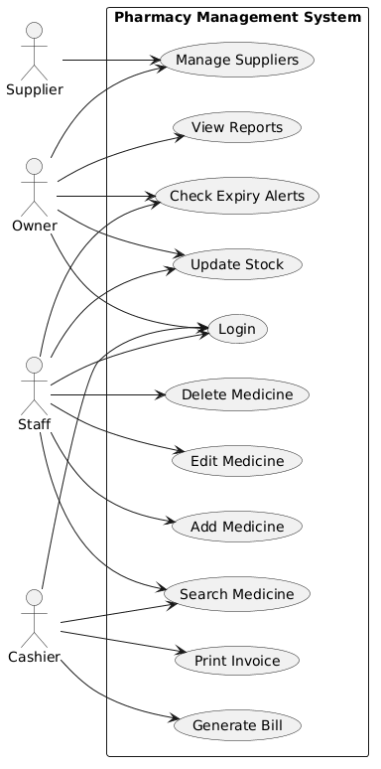
Figure 01: Use Case Diagram

12.2 Context Diagram
Below Figure-02 contain Context diagram shows the system as a single process and depicts how it interacts with external entities such as users, suppliers, and customers.
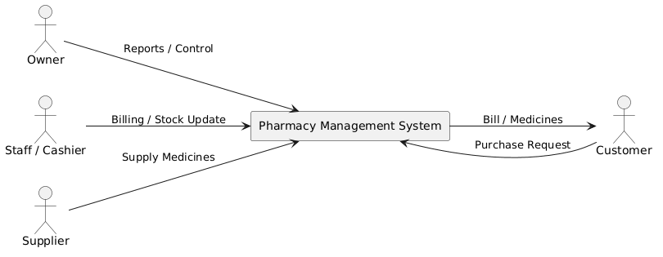
Figure 02: Context Diagram

12.3 Sequence Diagram
Below Figure-03 contains the Sequence Diagram, which shows the step-by-step interaction between users and the Pharmacy Management System over time. It illustrates how actors such as users, cashier, and owner communicate with different system modules like login, medicine management, billing, inventory, and reporting modules to complete various operations.
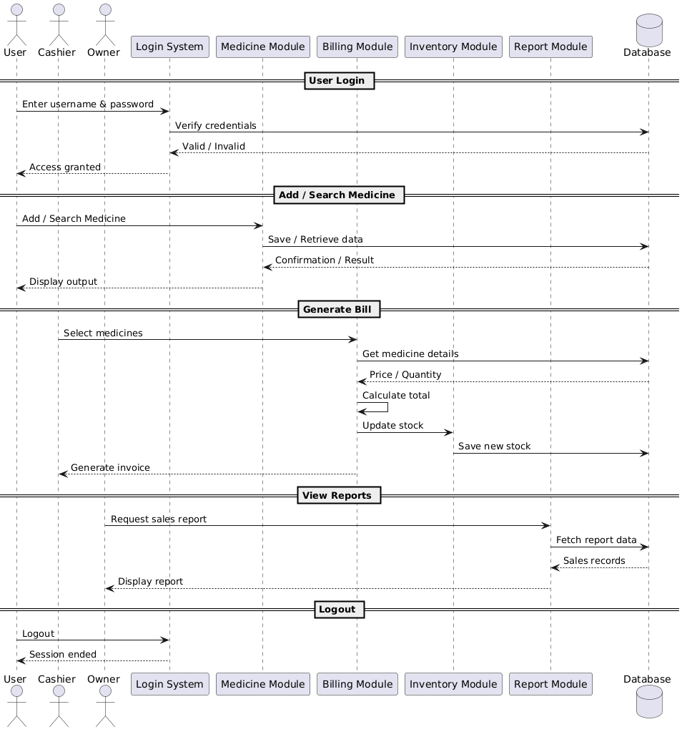
Figure 03: Sequence Diagram

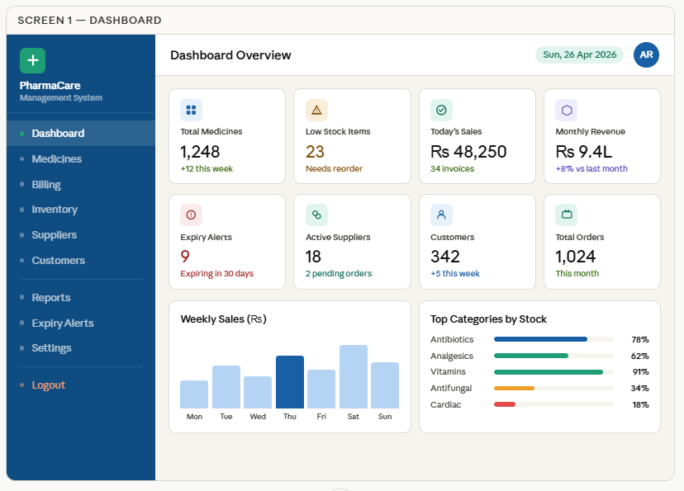
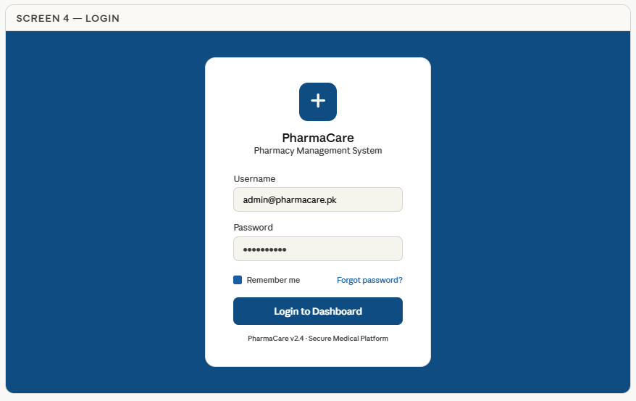
12.3 User Interface Mockups

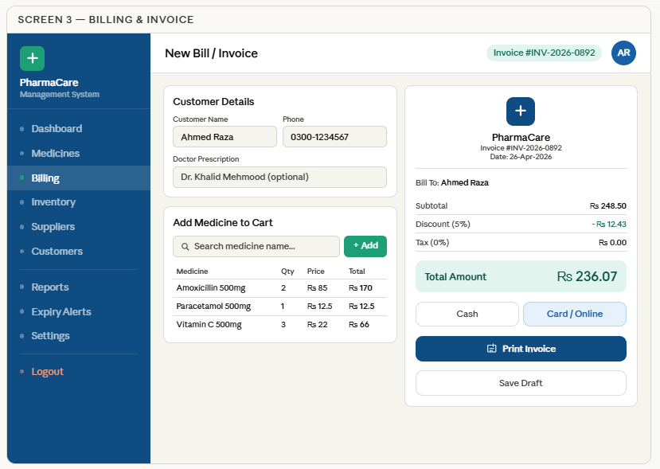
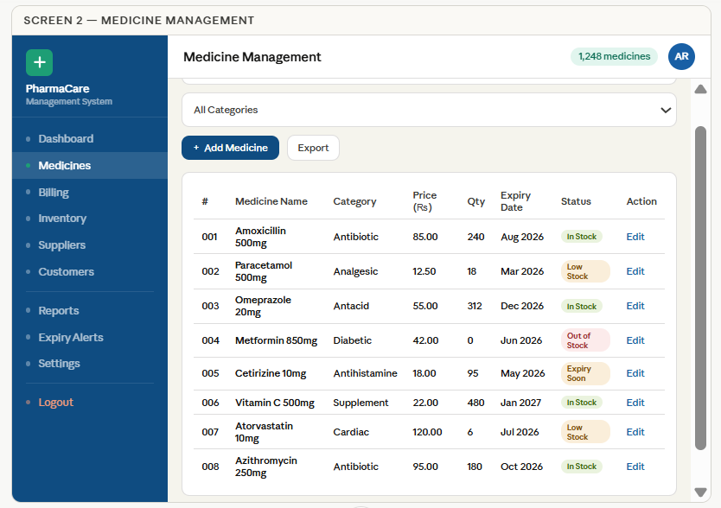

13. Proposed Solution
The Pharmacy Management System is a digital solution for pharmacy operations. It is based on the analysis of the manual system.
The Pharmacy Management System replaces paper registers with a database where medicine records can be stored and updated easily.
Medicine records can also be searched easily in the Pharmacy Management System. Staff can add medicine details quickly. Edit or delete them when needed. This keeps the inventory organized and accurate in the Pharmacy Management System.
The billing module in the Pharmacy Management System makes the sales process fast. It is easy to use the billing module in the Pharmacy Management System.
Staff can search for medicines. Add them to the bill quickly. They can generate invoices within seconds using the Pharmacy Management System. This reduces the time customers have to wait and improves the service quality of the Pharmacy Management System.
The stock management module in the Pharmacy Management System updates the quantity of medicines automatically. It does this after every sale or new purchase in the Pharmacy Management System.
The stock management module also gives alerts when the stock is low. This means medicines can be reordered on time in the Pharmacy Management System.
The expiry alert feature in the Pharmacy Management System helps staff identify medicines that're near expiry. This prevents the staff from selling expired medicines. Reduces losses in the Pharmacy Management System.
The supplier management module in the Pharmacy Management System stores supplier details. It also stores purchase records in one place. This makes it easier to manage orders in the Pharmacy Management System.
The reporting module in the Pharmacy Management System generates reports. These reports include sales and stock status. They also include revenue in the Pharmacy Management System. These reports help the owner make business decisions about the Pharmacy Management System.
In conclusion the Pharmacy Management System changes the pharmacy process. It turns it into an accurate digital system.
The Pharmacy Management System is also organized. It improves efficiency. Reduces errors, in the Pharmacy Management System.
The Pharmacy Management System provides management control.

14. Conclusion
The Pharmacy Management System is a helpful tool for local pharmacies that still do things by hand. We talked to people. Looked at what they need and it is clear that this system is necessary and can be put in place successfully.
The system takes care of things like logging in securely managing medicine, billing keeping track of stock, supplier records alerts for expired medicine and making reports. These things are what pharmacy owners and staff really need.
The Pharmacy Management System will make work better by making billing faster keeping stock records correct reducing mistakes and helping find expired medicines on time. It will also give reports to help make good business decisions.
In the future the Pharmacy Management System can have features like using it on mobile devices scanning barcodes ordering online and supporting many branches.
In conclusion the Pharmacy Management System is a way to start using modern technology. It makes the Pharmacy Management System more efficient, safer and easier to manage while helping pharmacies grow in a way. The Pharmacy Management System is a step toward digital transformation, for the Pharmacy Management System.

15. References
The following references were used in the preparation of this project report:
- Wiegers, Karl E. Software Requirements Engineering, Latest Edition. (Recommended Textbook for SWE-302 Course).
- Sommerville, Ian. Software Engineering, Latest Edition, Pearson Education Ltd.
- Class Lectures & Notes
- IEEE Software Requirements Specification (SRS) Standard for documentation format.

16. Appendices

16.1 Tool Used:
The following tools were used during preparation of this project:
- Microsoft Word – For report writing and formatting.
- Plant UML – For creating system diagrams.
- Claude.ai – For generating UI mockup designs and interface ideas.
- Google Search – For academic references and research material.

16.2 Plagiarism Report:


16.3 AI Report:
